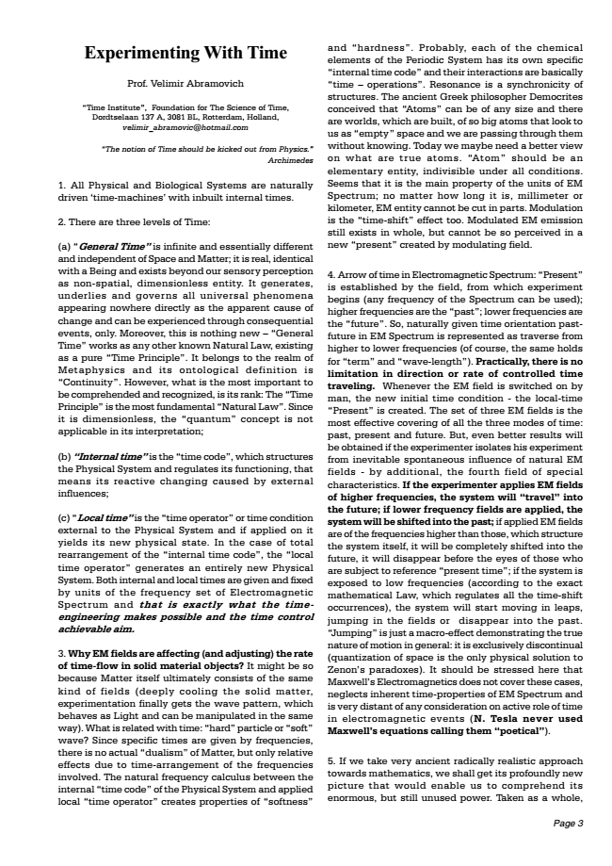
Experimenting With Time
Prof. Velimir Abramovich
Time Institute, Foundation for The Science of Time, Dordtselaan 137 A, 3081 BL, Rotterdam, Holland, velimir_abramovic@hotmail.com
The notion of Time should be kicked out from Physics. Archimedes
1. All Physical and Biological Systems are naturally driven time-machines with inbuilt internal times.
2. There are three levels of Time:
(a) General Time is infinite and essentially different and independent of Space and Matter; it is real, identical with a Being and exists beyond our sensory perception as non-spatial, dimensionless entity. It generates, underlies and governs all universal phenomena appearing nowhere directly as the apparent cause of change and can be experienced through consequential events, only. Moreover, this is nothing new  General Time works as any other known Natural Law, existing as a pure Time Principle. It belongs to the realm of Metaphysics and its ontological definition is Continuity. However, what is the most important to be comprehended and recognized, is its rank: The Time Principle is the most fundamental Natural Law. Since it is dimensionless, the quantum concept is not applicable in its interpretation;
(b) Internal time is the time code, which structures the Physical System and regulates its functioning, that means its reactive changing caused by external influences;
(c) Local time is the time operator or time condition external to the Physical System and if applied on it yields its new physical state. In the case of total rearrangement of the internal time code, the local time operator generates an entirely new Physical System. Both internal and local times are given and fixed by units of the frequency set of Electromagnetic Spectrum and that is exactly what the time- engineering makes possible and the time control achievable aim.
3. Why EM fields are affecting (and adjusting) the rate of time-flow in solid material objects? It might be so because Matter itself ultimately consists of the same kind of fields (deeply cooling the solid matter, experimentation finally gets the wave pattern, which behaves as Light and can be manipulated in the same way). What is related with time: hard particle or soft wave? Since specific times are given by frequencies, there is no actual dualism of Matter, but only relative effects due to time-arrangement of the frequencies involved. The natural frequency calculus between the internal time code of the Physical System and applied local time operator creates properties of softness
and hardness. Probably, each of the chemical elements of the Periodic System has its own specific internal time code and their interactions are basically time  operations. Resonance is a synchronicity of structures. The ancient Greek philosopher Democrites conceived that Atoms can be of any size and there are worlds, which are built, of so big atoms that look to us as empty space and we are passing through them without knowing. Today we maybe need a better view on what are true atoms. Atom should be an elementary entity, indivisible under all conditions. Seems that it is the main property of the units of EM Spectrum; no matter how long it is, millimeter or kilometer, EM entity cannot be cut in parts. Modulation is the time-shift effect too. Modulated EM emission still exists in whole, but cannot be so perceived in a new present created by modulating field.
4. Arrow of time in Electromagnetic Spectrum: Present is established by the field, from which experiment begins (any frequency of the Spectrum can be used); higher frequencies are the past; lower frequencies are the future. So, naturally given time orientation past- future in EM Spectrum is represented as traverse from higher to lower frequencies (of course, the same holds for term and wave-length). Practically, there is no limitation in direction or rate of controlled time traveling. Whenever the EM field is switched on by man, the new initial time condition - the local-time Present is created. The set of three EM fields is the most effective covering of all the three modes of time: past, present and future. But, even better results will be obtained if the experimenter isolates his experiment from inevitable spontaneous influence of natural EM fields - by additional, the fourth field of special characteristics. If the experimenter applies EM fields of higher frequencies, the system will travel into the future; if lower frequency fields are applied, the system will be shifted into the past; if applied EM fields are of the frequencies higher than those, which structure the system itself, it will be completely shifted into the future, it will disappear before the eyes of those who are subject to reference present time; if the system is exposed to low frequencies (according to the exact mathematical Law, which regulates all the time-shift occurrences), the system will start moving in leaps, jumping in the fields or disappear into the past. Jumping is just a macro-effect demonstrating the true nature of motion in general: it is exclusively discontinual (quantization of space is the only physical solution to Zenons paradoxes). It should be stressed here that Maxwells Electromagnetics does not cover these cases, neglects inherent time-properties of EM Spectrum and is very distant of any consideration on active role of time in electromagnetic events (N. Tesla never used Maxwells equations calling them poetical).
5. If we take very ancient radically realistic approach towards mathematics, we shall get its profoundly new picture that would enable us to comprehend its enormous, but still unused power. Taken as a whole,
Page 3

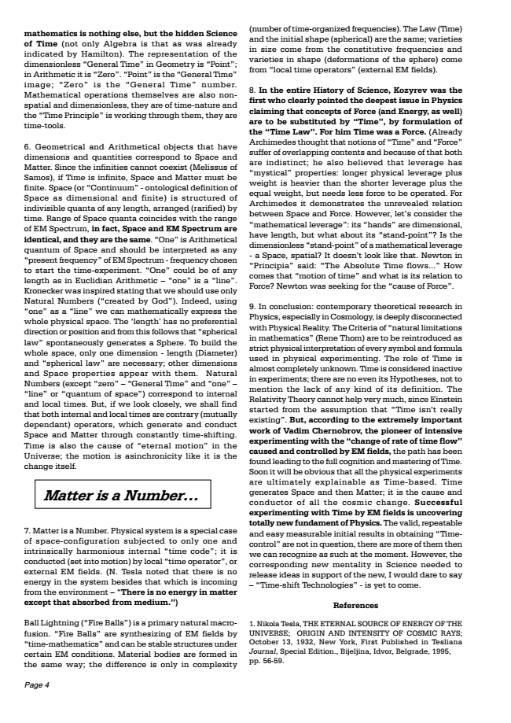
mathematics is nothing else, but the hidden Science of Time (not only Algebra is that as was already indicated by Hamilton). The representation of the dimensionless General Time in Geometry is Point; in Arithmetic it is Zero. Point is the General Time image; Zero is the General Time number. Mathematical operations themselves are also non- spatial and dimensionless, they are of time-nature and the Time Principle is working through them, they are time-tools.
6. Geometrical and Arithmetical objects that have dimensions and quantities correspond to Space and Matter. Since the infinities cannot coexist (Melissus of Samos), if Time is infinite, Space and Matter must be finite. Space (or Continuum - ontological definition of Space as dimensional and finite) is structured of indivisible quanta of any length, arranged (rarified) by time. Range of Space quanta coincides with the range of EM Spectrum, in fact, Space and EM Spectrum are identical, and they are the same. One is Arithmetical quantum of Space and should be interpreted as any present frequency of EM Spectrum - frequency chosen to start the time-experiment. One could be of any length as in Euclidian Arithmetic  one is a line. Kronecker was inspired stating that we should use only Natural Numbers (created by God). Indeed, using one as a line we can mathematically express the whole physical space. The length has no preferential direction or position and from this follows that spherical law spontaneously generates a Sphere. To build the whole space, only one dimension - length (Diameter) and spherical law are necessary; other dimensions and Space properties appear with them. Natural Numbers (except zero  General Time and one  line or quantum of space) correspond to internal and local times. But, if we look closely, we shall find that both internal and local times are contrary (mutually dependant) operators, which generate and conduct Space and Matter through constantly time-shifting. Time is also the cause of eternal motion in the Universe; the motion is asinchronicity like it is the change itself.
Matter is a Number
7. Matter is a Number. Physical system is a special case of space-configuration subjected to only one and intrinsically harmonious internal time code; it is conducted (set into motion) by local time operator, or external EM fields. (N. Tesla noted that there is no energy in the system besides that which is incoming from the environment  There is no energy in matter except that absorbed from medium.)
Ball Lightning (Fire Balls) is a primary natural macro- fusion. Fire Balls are synthesizing of EM fields by time-mathematics and can be stable structures under certain EM conditions. Material bodies are formed in the same way; the difference is only in complexity
Page 4
(number of time-organized frequencies). The Law (Time) and the initial shape (spherical) are the same; varieties in size come from the constitutive frequencies and varieties in shape (deformations of the sphere) come from local time operators (external EM fields).
8. In the entire History of Science, Kozyrev was the first who clearly pointed the deepest issue in Physics claiming that concepts of Force (and Energy, as well) are to be substituted by Time, by formulation of the Time Law. For him Time was a Force. (Already Archimedes thought that notions of Time and Force suffer of overlapping contents and because of that both are indistinct; he also believed that leverage has mystical properties: longer physical leverage plus weight is heavier than the shorter leverage plus the equal weight, but needs less force to be operated. For Archimedes it demonstrates the unrevealed relation between Space and Force. However, lets consider the mathematical leverage: its hands are dimensional, have length, but what about its stand-point? Is the dimensionless stand-point of a mathematical leverage - a Space, spatial? It doesnt look like that. Newton in Principia said: The Absolute Time flows... How comes that motion of time and what is its relation to Force? Newton was seeking for the cause of Force.
9. In conclusion: contemporary theoretical research in Physics, especially in Cosmology, is deeply disconnected with Physical Reality. The Criteria of natural limitations in mathematics (Rene Thom) are to be reintroduced as strict physical interpretation of every symbol and formula used in physical experimenting. The role of Time is almost completely unknown. Time is considered inactive in experiments; there are no even its Hypotheses, not to mention the lack of any kind of its definition. The Relativity Theory cannot help very much, since Einstein started from the assumption that Time isnt really existing. But, according to the extremely important work of Vadim Chernobrov, the pioneer of intensive experimenting with the change of rate of time flow caused and controlled by EM fields, the path has been found leading to the full cognition and mastering of Time. Soon it will be obvious that all the physical experiments are ultimately explainable as Time-based. Time generates Space and then Matter; it is the cause and conductor of all the cosmic change. Successful experimenting with Time by EM fields is uncovering totally new fundament of Physics. The valid, repeatable and easy measurable initial results in obtaining Time- control are not in question, there are more of them then we can recognize as such at the moment. However, the corresponding new mentality in Science needed to release ideas in support of the new, I would dare to say  Time-shift Technologies - is yet to come.
References
1. Nikola Tesla, THE ETERNAL SOURCE OF ENERGY OF THE UNIVERSE; ORIGIN AND INTENSITY OF COSMIC RAYS; October 13, 1932, New York, First Published in Tesliana Journal, Special Edition., Bijeljina, Idvor, Belgrade, 1995, pp. 56-59.

